NAME: …………………………………………………………… INDEX NO. …………………………
SCHOOL: ………………………………………………………...CANDIDATE’S SIGN. …………............
DATE: ………………………………............................................

232/2
PHYSICS THEORY
PAPER 2
MAY /JUNE 2017
TIME: 2 HOURS

Kenya Certificate of Secondary Education (K.C.S.E.)
LORETO LIMURU-MARY HILL (LOMH) JOINT EXAMINATION
FORM 4 PRE-MOCK EXAMINATION

232/2
Physics
Paper 2
INSTRUCTIONS TO THE CANDIDATES:
- Write your name and index number in the spaces provided above.
- Answer all the questions both in section A and B in the spaces provided below each question
- All workings must be clearly shown; marks may be awarded for correct steps even if the answers are wrong.
- Mathematical tables and silent electronic calculators may be used.
For Examiners’ Use Only
SECTION | QUESTION | MAXIMUM SCORE | CANDIDATE’S SCORE
Section A | 1-12 | 25
Section B | 13 | 10
Section B | 14 | 14
Section B | 15 | 13
Section B | 16 | 10
Section B | 17 | 08
Section B | TOTAL | 80

This paper consists of 14 printed pages. Candidates should check to ascertain that all pages are printed as indicated and that no questions is missing

SECTION A :( 25 MARKS)
ANSWER ALL QUESTIONS IN THIS SECTION IN THE SPACES PROVIDED.

- Figure 1 shows two mirrors M₁ and M₂ placed at an angle of 80°. A ray of light incident to the mirror makes an angle of 45° with the mirror M₁. Find the angle the ray turns after reflection in the two mirrors. (3marks)
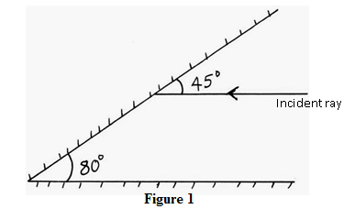
………………………………………………………………………………………………………………… ………………………………………………………………………………………………………….……………………………………………………………………….……………………………………………………………………………..………………………………………………………………………………………
- Figure 2 shows two charged spheres A and B. If the two spheres are brought into contact and then separated complete the diagram showing charge distribution on the two spheres after separation. (2marks)

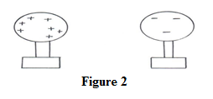

………………………………………………………………………………………………………………… ………………………………………………………………………………………………………….……………………………………………………………………….……………………………………………………………………………..………………………………………………………………………………………

- Explain how polarization reduces the emf in a simple cell. (1mark)

………………………………………………………………………………………………………………… ………………………………………………………………………………………………………….……………………………………………………………………….……………………………………………………………………………..………………………………………………………………………………………

- Figure 3 shows a method of magnetization.
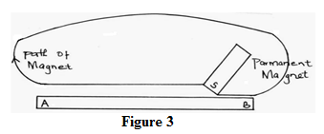

Ferromagnetic material is being magnetized sketch a graph to show how the strength of a magnet being created varies with the number of strokes. (2marks)

Number of strokes
Magnetic strength

- The figure below shows the magnetic field between two parallel current carrying conductors A and B placed close to one another current flows in the opposite directions.

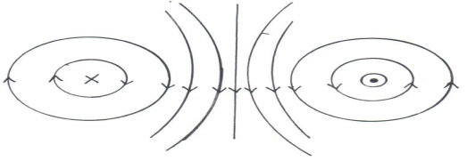

Indicate the direction of force F, due to the current on each conductor.

- The figure below show water waves moving from a shallow region to a deep region. Complete the diagram to show the appearance of the waves in the deeper region. (2marks)
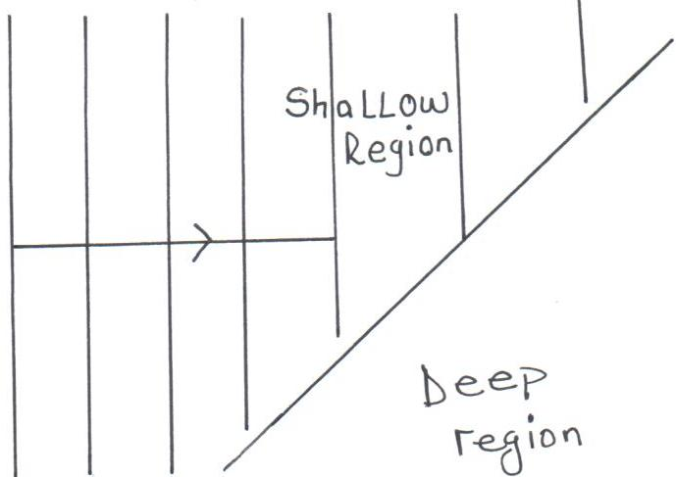

- An echo sounder produces a pulse and an echo is received from the sea bed after 0.4 seconds. If the speed of sound in water is 1500m/s. Calculate the depth of the sea bed. (2marks)

………………………………………………………………………………………………………………… ………………………………………………………………………………………………………….……………………………………………………………………….……………………………………………………………………………..………………………………………………………………………………………

- The diagram below shows a ray of light travelling from water to glass given that the refractive index of water and glass are 1.33 and 1.5 respectively find the angle of refraction in glass. (3marks)
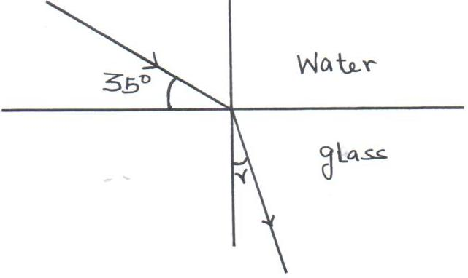

……………………………………………………………………………………………………………… ………………………………………………………………………………………………………….……………………………………………………………………….……………………………………………………………………………..………………………………………………………………………………………
- Below is part of the electromagnetic spectrum in order of increasing wavelength.
A | B | C | Visible light | Infra-red | D | E

How are waves A produced? (2marks)
………………………………………………………………………………………………………………… ………………………………………………………………………………………………………….……………………………………………………………………….……………………………………………………………………………..………………………………………………………………………………………

- The figure below shows an image formed by concave mirror. Complete the drawing rays and locate the position of the object. (2marks)

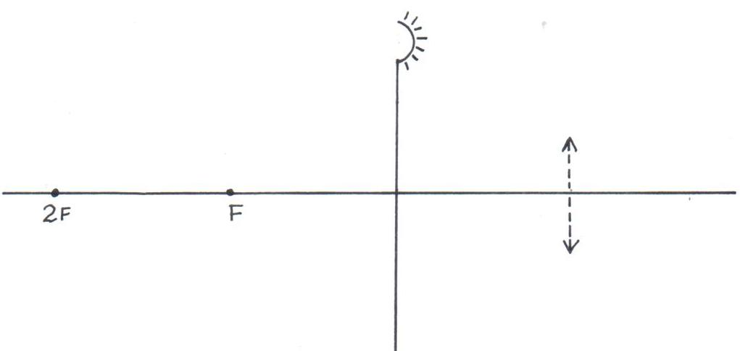

- The figure below shows capacitors connected to a d.c. supply.

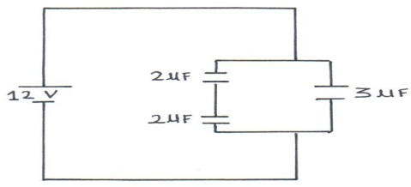

Determine the charge stored in the 3μF capacitor. (3marks)

………………………………………………………………………………………………………………… ………………………………………………………………………………………………………….……………………………………………………………………….……………………………………………………………………………..………………………………………………………………………………………
- A pendulum bob takes 0.5 seconds to move from its mean position to a maximum displacement position. Calculate its frequency. (2marks)

………………………………………………………………………………………………………………… ………………………………………………………………………………………………………….……………………………………………………………………….……………………………………………………………………………..………………………………………………………………………………………

SECTION B: (55 MARKS)
ANSWER ALL QUESTIONS IN THIS SECTION IN THE SPACES PROVIDED.

- A defective eye focuses a near object as shown in the figure below.
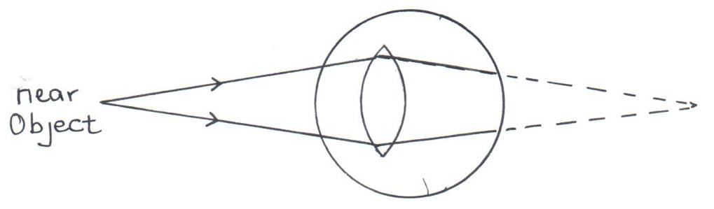

- State the defect. (1mark)

………………………………………………………………………………………………………………… ………………………………………………………………………………………………………….………
- Suggest a suitable lens that can be used to correct the defect. (1mark)

………………………………………………………………………………………………………………… ………………………………………………………………………………………………………….………
- Draw a diagram to illustrate the correction of the defect. (2marks)

………………………………………………………………………………………………………………… ………………………………………………………………………………………………………….………

- A real image, half the size of the object is formed by a lens. If the distance between the object and the image is 450mm. Determine the focal length of the lens. (3marks)

……………………………………………………………………………………………………………………………………………………………………………………………………………………….……………………………………………………………………….……………………………………………………………………………..……………………………………………………………………………………………
- The figure below shows a virtual image formed by a convex lens. Complete the ray diagram to show the position of the object. (3marks)
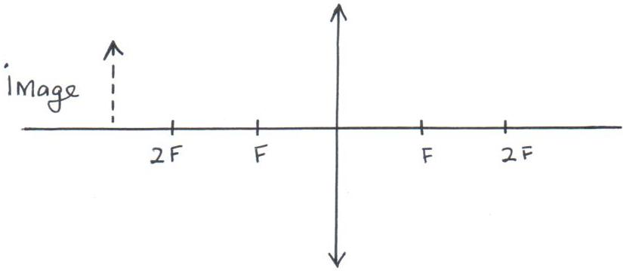

- The figure shows capacitors C₁ and C₂ connected in series .they are connected to a battery of potential difference V volts
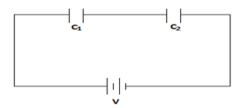
In terms of Q, C₁ and C₂, write an expression for
- Voltage V₁ across C₁ (1 mark)
……………………………………………………………………………………………………………………………………………………………………………………………………………………….……………

- Voltage V₂ across C₂ (1 mark)
……………………………………………………………………………………………………………………………………………………………………………………………………………………….……………

- Total voltage in the circuit (1 mark)
……………………………………………………………………………………………………………………………………………………………………………………………………………………….……………
- Show that the total capacitance C_{T} is given by (3 marks)
…………………………………………………………………………………………………………………………………………………………………………………………………………………….……………………………………………………………………….……………………………………………………………………………..……………………………………………………………………………………………
- The factors that affect the capacitance of a parallel-plate capacitor are area of plates and distance between the parallel plates .explain how each of the factors affects capacitance
- Distance of separation between the plates (1 mark)
……………………………………………………………………………………………………………………………………………………………………………………………………………………….……………
- Area of overlap of the plates (1 mark)
………………………………………………………………………………………………………………………………………..……………………………………………………………………………………………
- In the circuit below, the e.m.f of the cell is 2.1V and has an internal resistance of 0.5Ω.
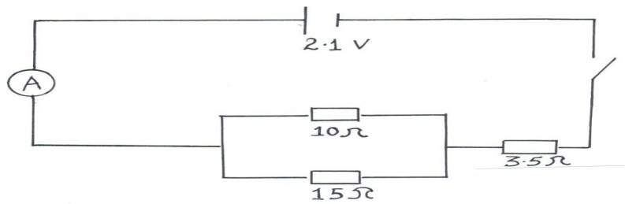

- Determine the effective resistance in the circuit. (3marks)
…………………………………………………………………………………………………………………………………………………………………………………………………………………….……………………………………………………………………….……………………………………………………………………………..………………………………………………………………………………………………
- Determine the ammeter reading when the switch is closed. (3marks)
………………………………………………………………………………………………………………… ………………………………………………………………………………………………………….……………………………………………………………………….……………………………………………………………………………..………………………………………………………………………………………

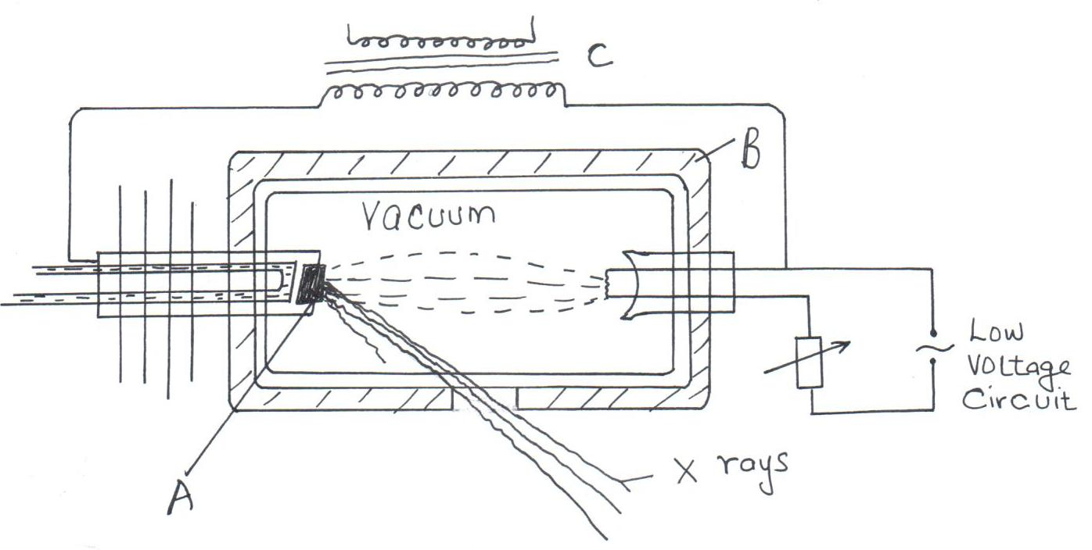
- The figure below shows an X-ray tube.

- Name the elements used in making the parts labelled A and B. (2mks)

A………………………………………………………………………………………………

B………………………………………………………………………………………………

- Explain the use of the part labelled C. (1mark)

………………………………………………………………………………………………………………… ………………………………………………………………………………………………………….………
- Explain how the X-rays are produced. (2marks)

………………………………………………………………………………………………………………… ………………………………………………………………………………………………………….……………………………………………………………………….……………………………………………………………………………..………………………………………………………………………………………

- Why is the X-ray tube evacuated? (1mark)

………………………………………………………………………………………………………………… ………………………………………………………………………………………………………….………

- The penetrating power of X-rays is normally varied depending on the intended use. Explain briefly how this is done. (1mark)
………………………………………………………………………………………………………………… ………………………………………………………………………………………………………….………

- The energy of X-rays is 1.989 × 10ˉ¹⁴ joules. Given that the speed of light is 3.0 × 10⁸m/s and plank’s constant is 6.63 × 10⁻³⁴JS. Find the wavelength of the X-rays. (3marks)

………………………………………………………………………………………………………………… ………………………………………………………………………………………………………….……………………………………………………………………….……………………………………………………………………………..………………………………………………………………………………………
- The figure below shows a wave form displayed on the screen of C.R.O when the time base is set at 20ms per division.
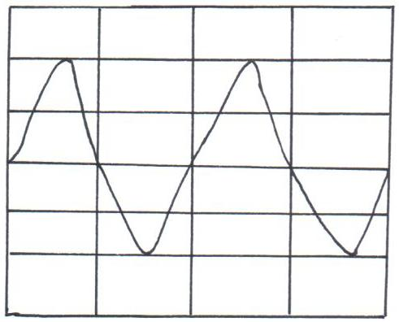

Determine the frequency of the signal. (3marks)
………………………………………………………………………………………………………………… ………………………………………………………………………………………………………….……………………………………………………………………….……………………………………………………………………………..………………………………………………………………………………………

- Give a condition necessary for electrons to be emitted from the cathode of a photocell. (1mark)

………………………………………………………………………………………………………………… ………………………………………………………………………………………………………….………
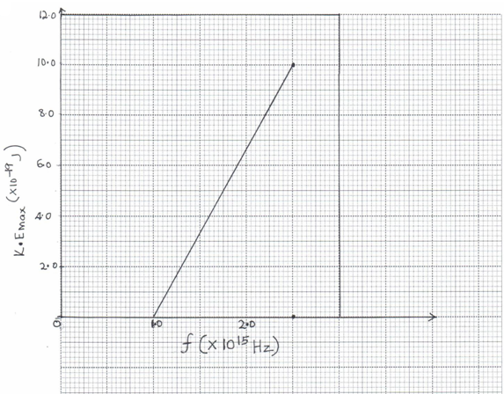
- In an experiment using a photocell, ultraviolet light of varying frequency strikes a metal surface. The maximum Kinetic Energy (K.E_{max}) of photoelectrons for each frequency is measured. The graph below shows how the maximum kinetic energy varies with the frequency.

Use the graph to determine:
- The Threshold frequency, . (2 marks)
………………………………………………………………………………………………………………… ………………………………………………………………………………………………………….………

- Planck’s constant, h. (3marks)

………………………………………………………………………………………………………………… ………………………………………………………………………………………………………….……………………………………………………………………….……………………………………………………………………………..………………………………………………………………………………………

- Work function of the metal. (3marks)

………………………………………………………………………………………………………………… ………………………………………………………………………………………………………….……………………………………………………………………….……………………………………………………………………………..………………………………………………………………………………………
- The figure below shows the variation of photoelectric current with applied voltage when a surface was illuminated with light of a certain frequency. On the same axes, sketch the graph when a light of higher intensity but same frequency is used to illuminate the same surface. (1mark)

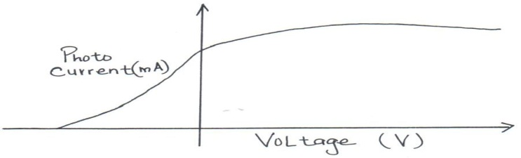

- Define the term half-life of a radioactive material. (1mark)
………………………………………………………………………………………………………………… ………………………………………………………………………………………………………….………
- The figure below shows a decay of a certain element. The diagram is drawn to scale.
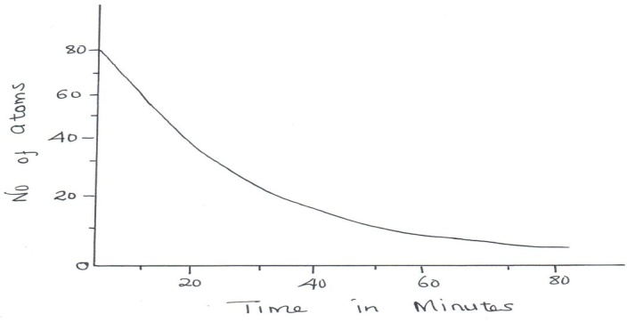

From the graph find:
- Half-life of the element. (2mark)

………………………………………………………………………………………………………………… ………………………………………………………………………………………………………….……………………………………………………………………….……………………………………………………………………………..………………………………………………………………………………………

- Number of half-lives undergone when the count rate is 10 atoms. (3marks)

………………………………………………………………………………………………………………… ………………………………………………………………………………………………………….……………………………………………………………………….……………………………………………………………………………..………………………………………………………………………………………
- The following is part of a radioactive decay series.
Determine the value of ‘a’ and ‘b’. (2marks)

………………………………………………………………………………………………………………… ………………………………………………………………………………………………………….………

