Name: …………………………………………………………… Index No. …………………………
School: …………………………………………………………. Candidate’s Sign. …………............
Date: ………………………………............................................

232/1
PHYSICS THEORY
PAPER 1
JULY 2017
TIME: 2 HOURS

LORETO LIMURU, MARY HILL GIRLS AND NAIROBI SCHOOL JOINT
EVALUATION EXAMINATION - 2017
Kenya Certificate of Secondary Education (K.C.S.E)

232/1
Physics
Paper 1

INSTRUCTIONS TO THE CANDIDATES:
- Write your name and index number in the spaces provided above.
- Answer all the questions both in section A and B in the spaces provided below each question
- All workings must be clearly shown; marks may be awarded for correct steps even if the answers are wrong.
- Mathematical tables and silent electronic calculators may be used.
For Examiners’ Use Only
SECTION | QUESTION | MAXIMUM SCORE | CANDIDATE’S SCORE
Section A | 1-13 | 25
Section B | 14 | 12
Section B | 15 | 12
Section B | 16 | 13
Section B | 17 | 14
Section B | 18 | 04
Section B | TOTAL | 80

This paper consists of 11 printed pages. Candidates should check to ascertain that all pages are printed as indicated and that no questions is missing
SECTION A (25 MARKS)
ANSWER ALL QUESTIONS IN THIS SECTION IN THE SPACES PROVIDED
- The figure below shows a metre rule that was used by a student to measure the lengthy of a rod.
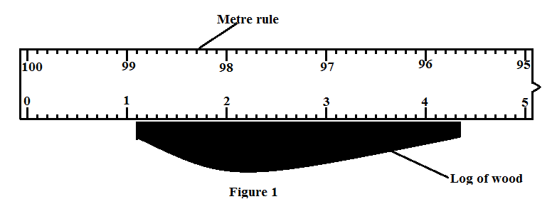

Determine the length of the rod the student should record (2 marks)
$$Length of the rod=4.3-1.1$$
$$=3.2cm±0.1$$

- State the accuracy of the metre rule used (1 mark)
$$0.1cm$$
- A lift pump can only lift water to a maximum height of 10m. Give a reason for this observation (1 mark)
It depends on the atmospheric pressure which can only support a water column of 10m

- A highly inflated balloon is likely to burst when released out in the sun for some time. Explain this observation (2 marks)
The temperature out in the sun is slightly higher. This increases the kinetic energy of the gas particles. The particles collide more with the walls of the balloon thereby generating a higher pressure to burs the balloon

- Figure 13 shows a beaker filled with a liquid to a height h and a uniform cross-section area A. given that the density of the liquid is ρ and its volume is V.
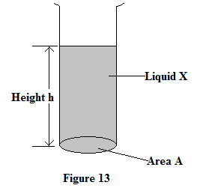
Show that the P exerted by the water at the base $P=hρg$ where P is the pressure and g is the gravitational field strength (3 marks)

$$Mass of the liquid=Vρ$$
$$Weight or Force of the liquid =Vρg$$
$$but V=Ah$$
$$Weight=Ahρg$$
$$Pressure=\frac{Force }{Area }$$
$$Pressure=\frac{Ahρg}{A}$$
$=hρg$

- Explain why a concrete floor feels cold to the feet than a carpet floor. (2 marks)
Concrete floor is a good conductor of heat and a carpet is a poor conductor of heat. The concrete therefore conducts heat thus leaving one feeling cold.

- Name the principle on which a hydraulic press depends on its working. (1 mark)
Principle of transmission of pressure in a fluid/Pascal’s principle

- Figure 8 shows two levels of two different liquids A and B after air was sucked out from the tubes . study the diagram below and answer the questions that follow
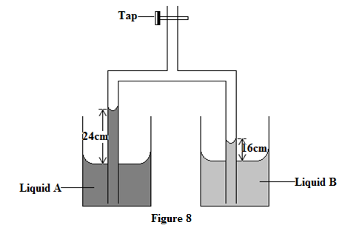

Explain the reason for the rise in level of the liquids when air is sucked out from the tubes (2 marks)
When air is sucked out, a partial vacuum is created thereby lowering pressure inside the tube; greater atmospheric pressure acting on the liquid pushes the liquid level up the tub$e$
- One way of making liquid in glass thermometer more sensitive is by using a narrow capillary bore. State the other method (1 mark)
Using a thin walled glass bulb (reject thin bulb)
- Figure 7 shows a stable wine glass placed on a flat surface. . Explain how the stability of the glass is affected as water is slowly poured into the glass (2marks)
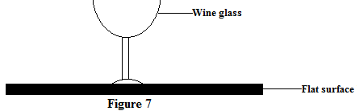

The glass becomes unstable as water is poured into it
Addition of water makes the upper part to be heavier than the bottom

- Figure 2 shows a spray gun. Study it and answer the questions that follow
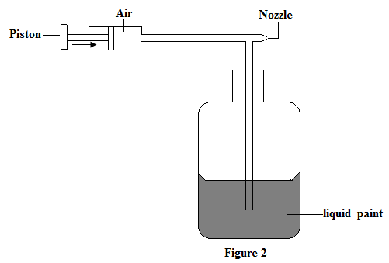
Explain how the liquid paint is sprayed when the piston is pushed in the direction shown in the diagram (3 arks)
When the piston is pushed, air enters the narrow section at a higher velocity. This makes the pressure in the narrow tube to be lower than the pressure inside the container of the liquid paint. The higher atmospheric pressure in the tube therefore pushes the liquid paint up the tube where it is sprayed out through the nozzle

- The following set-up was used to study the behavior of smoke particles. Study it and answer the questions that follow
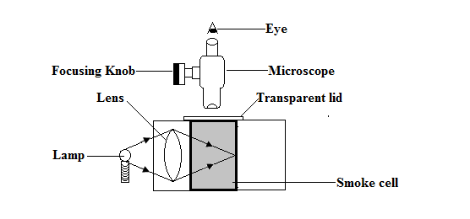
State two reasons why smoke particles are preferred for use in the smoke cell (2 marks)
The smoke particles are lighter
The smoke particles produce bright specks hence easy to observe

The figure shows a simple fire alarm. Study it and answer the questions 13 and 14 that follow
- One of the reasons why mercury is preferred is that it is a good conductor of heat. State the other reason. (1 mark)
Mercury conducts electric current
- Explain how the bell rings when the temperature increases (2 marks)
Temperature cause the mercury to expand and complete the circuit
Current flows in the circuit to make the bell ring
One reason why mercury is prefeferd to water for use in the alarm is that mercury expand

SECTION B (55 MARKS)
ANSWER ALL QUESTIONS IN THIS SECTION IN THE SPACES PROVIDED

- The figure below shows a displacement- time graph for a particular body. Study it and answer the questions that follow
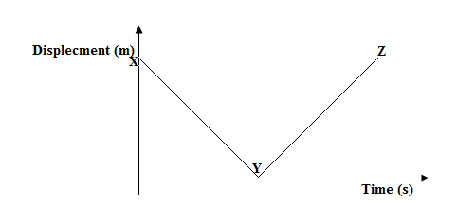
Describe the motion of the body (2marks)

- Figure 16 below shows a block of resting on a rough surface. Study the diagram and answer the questions that follow
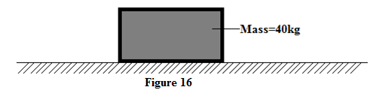
- Show on the diagram the one force that act on the block when it is at rest (1 mark)

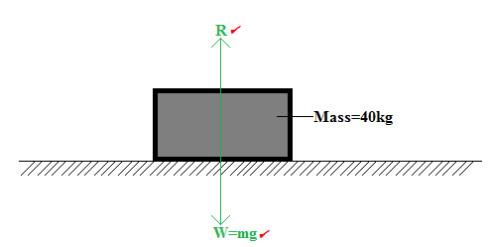

- Given that the co-efficient of friction of the block is 0.6N. Determine;
- The friction force on the block (2 marks)
$$F=µR$$
$$F=0.6×400$$
$$=240N$$

- The acceleration on the block if a pulling force of 300N is applied on the block (2 marks)
$$Net force=Applied force-Frictional force$$
$$300N-240=60N$$
$$60N=40×a$$
$$a=1.5{m/s}^{2}$$
- A body is moving along a circular path with a constant speed of 30m/s.Give a reason why the body is said to be accelerating (1mark)
This is because in a circular path, There is continuos change in direction of motion of the object causing a changé in velocity hence acceleration
- Figure 10 shows a metal block of mass 400g is placed on a frictionless rotating table while fixed at the centre of the table by a thin thread
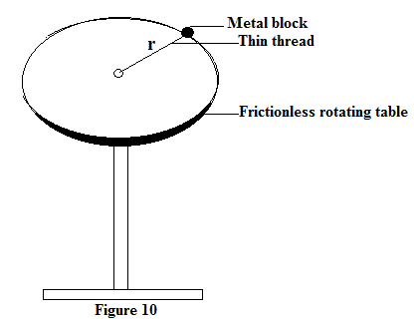

- Given that the length of the thread is 20cm and that the thread can only withstand a tension of 7.2N, determine the maximum angular velocity for the turn table before the thread breaks (3marks)
$$Centripetal force=Tension on the string$$
$$7.2N=0.4×ω^{2}×0.2$$
$$ω^{2}=\frac{7.2}{0.4×0.2}$$
$$ω=9.49rad/s$$
- State the effect of decreasing the length of the thin thread on the centripetal force acting on the metal block(1 mk)
The centripetal force increases

- State the two factors that will increase the critical speed of a car negotiating a bend on a flat level road (2marks)
Radius of the bend
Conditions of the tyres
The nature of the road surface

- Figure shows a roller coaster rolling on a track. The speed of the roller coaster at point A is 5.0m/s
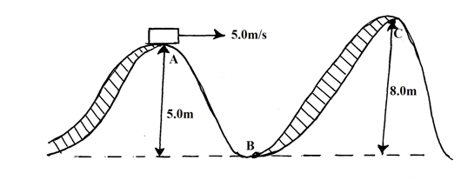
Determine
- The speed of the roller coaster at B (3 marks)
Total energy at A = total energy at B1
½ mVa² + mgh = ½ mv²_{b} since P.E at B = 0
½ Va² + gh = ½ Vb²
½ x 5² + 10x5 = ½ Vb²1
2(12.5 + 50) = Vb²
125 = Vb²
V_{B} = 11.18m/s1
- Speed at A is required for the roller coaster to reach point C (2 marks)
½ Mv²_{A} + mgha = mghc1
½ v²_{A} + gha = ghc
v²_{A} = 2ghc – 2gha
= 2x10x8 – 2x10x51
v²_{A} = 60
V_{A} = 7.75m/s1

- Figure below shows two pulley arrangements used to lift different loads.
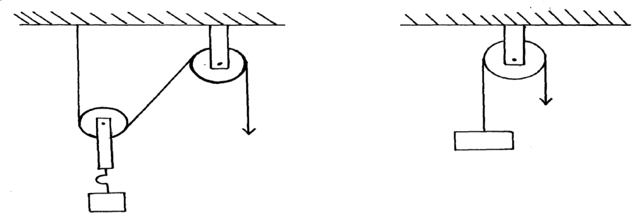
Y
X
Effort
Effort
10kg
1kg
State with a reason which of the systems, between X and Y is more efficient. (2 marks)
Effect of the weight of movable pulley reduces efficiency of X; Load in Y is larger and so effect of friction is less in Y thereby increasing efficiency. √

- The following diagram shows a load of 50N being raised by pulling it along an Inclined plane of length 2.0m
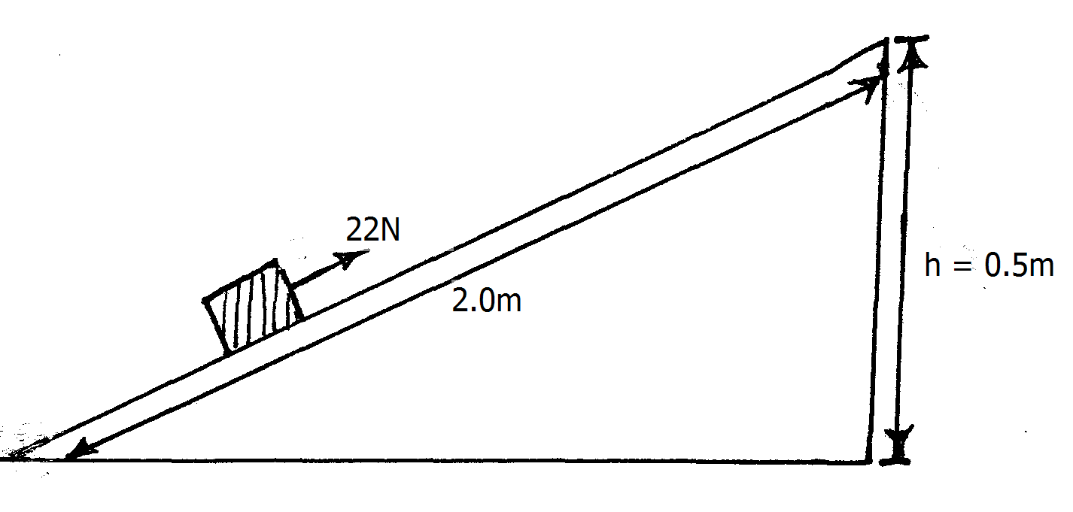
Determine
- The work done by the 22N force (2 marks)
Work done = Force x distance
= 22 x 2 = 44Nm (J)
- The work done against the load (2 marks)
Work done = mgh
= 50 x 0.5m = 25J
- The efficiency of the system (2 marks)
Efficiency=$\frac{work output}{work input} x 100\%$ =$\frac{25 x 100\%}{44}$ = 56.82%
- give one reason why the efficiency less than 100% (1 mark)

Friction along the inclined plane

- The figure below shows a test-tube of uniform cross-section area 120cm³ and total mass 15g modified as hydrometer. The test tube is partially immersed in a liquid of density 0.8g/cm³. Study the diagram and answer the questions that follow

State the function of a hydrometer (1 mark)
To measure relative density of a liquid
- Determine
- The weight of the hydrometer (2 marks)
$$Weight=mg=\frac{15}{1000}×10$$
$$=0.15N$$
- The upthrust exerted by the liquid on the hydrometer (1 mark)
$$Upthrust=weight of the test-tube$$
$$=0.15N$$
- The volume of the hydrometer below the surface of the liquid (2 marks)
$$Upthrust=Weight of the fluid displaced$$
$$0.15N=Vρg=V×800×10$$
$$V=\frac{0.15}{8000}$$
$$={1.875×10}^{-5}m^{3}$$
- The height in cm of the hydrometer below the surface of the liquid (2 marks)
$$Volume=Cross-section area ×height$$
$${1.875×10}^{-5}m^{3}={3.0×10}^{-5} ×h$$
$$h=\frac{{1.875×10}^{-5}m^{3}}{{1.2×10}^{-4}}$$
$$=0.15625m$$
$$=15.63cm$$

- When the part marked X is made narrower while the volume remains constant, it is observed that the hydrometer sinks more in the liquid. Explain this observation (2 marks)
Making it narrower reduces the cross-section area while the weight remains the same. The hydrometer therefore sinks more to displace more volume of the liquid to support its weight

- A certain solid of volume 52cm³ displaces 8.5cm³ of kerosene (density 800kgm⁻³) when floating. Determine the density of the solid. (2 marks)

Weight of solid = weight of kerosene displaced
Mass of kerosene displaced =0.8 x 8.5=6.8g
Density of the solid =$\frac{6.8g}{52}$
=0.13g/cm³

- A glass block is suspended from a spring balance and held inside a beaker without touching the beaker. Water is slowly added into the beaker until the glass block is fully immersed in the water. The figure below shows the graph of variation of upthrust on the block and the its depth in the water as water is added
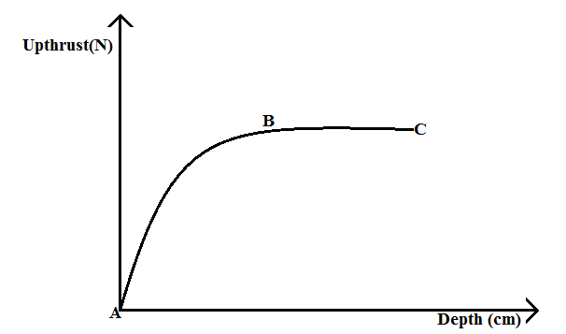
State and explain the variation in upthrust and depth at the between the points B-C (2 marks)
The upthrust remains constant despite increase in the depth. This is because the glass block is already fully submerged hence the upthrust has reached a maximum magnitude

State 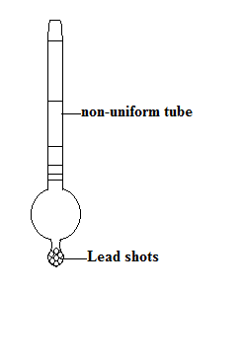

- 5 grams of water at 20ºC is heated until it boils at 95ºC. On further heating the temperature of the water does not change until it has all evaporated.
- State what happens to the energy supplied to the water after attaining a temperature of 95ºC. (1 mark)
The heat is used in breaking the bonds/vaporizing the water; (latent heat of vaporization)

- Calculate the amount of heat required to convert all the 5g of water to steam.(Latent heat of vaporization of water=2260000J/kg) (4 marks)

Q₁ =Mc∆θ : (heat gained by changing the temp.)
= 5 x 10⁻³ x 4200 x (95 – 20)
= 1.575J;
Q₂ = ${mL}_{v}$ (Heat to vaporize the water)
= 5 x 10⁻³ x 2.26 x 10⁶
= 11.3kJ;
Q_{Total} = Q₁ + Q₂
= 1.575 + 11.3
= 12.875kJ

- The figure shows a set-up of a cylinder with uniform cross-section area that was used to determine the relationship between the pressure P and volume V of a fixed mass of gas at constant temperature

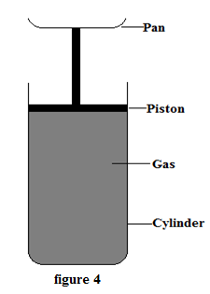

Various masses were placed on the pan and the corresponding volume of gas in the cylinder measured and recorded in the table below

Pressure, P, Nm⁻² x 10⁵ | 1.00 | 1.20 | 1.40 | 1.60 | 1.80
1 (v) x 10⁻²(m⁻³)  volume | 1.61 | 1.92 | 2.22 | 2.56 | 2.85

- Plot a graph of P against$1/V$ (5marks)

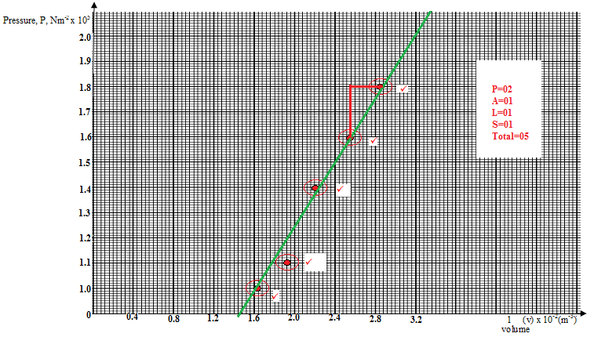

- Given that P=$\frac{75 R}{ V}$ where R is a constant, use the graph to determine the value of R (3marks)
Slope of the line =$\frac{Δy}{Δx}$
$\frac{20000}{0.0029}=6896551.724$
$but 75R=6896551.724$
$R=91954.02$

