SECTION A: ( 25marks)
Answer all the questions in the spaces provided
1.State a property of electromagnetic wave on which the operation of a radar system is based The waves can be reflected

2. In determining the depth of an ocean, an echo sounder producing ultrasonic sound is used. Give one reason why this sound is preferred. (1mark)
Penetrate deepest.
Reflected easily by tiny grains
3. Figure 1 below shows a simple experiment using a permanent magnet and two metal
bars X and Y put closer the iron fillings.
S
N
Y
X
a).During attraction
X
Y
b). After attraction

State with a reason which bar is made from a soft magnetic material. (2 marks)
Y;
Attracts more iron fillings since it forms a stronger magnet;

4. State the purpose of manganese (IV) oxide in a dry cell. (1 mark)
Acts as a depolarizer
5.State two advantages of using a convex mirrors to monitor movements in a large supermarket (2marks)
-It provides a larger field of view
-It forms an upright image,(regardless of the object distance)
6.The figure 2 below shows two bar magnets and a plotting compass.
Draw the magnetic field pattern round the bar magnets indicating the polarity of each. (2marks)
S
N
S
N
- Naming polarities
- Field pattern with direction
7.Figure 3 shows a virtual image I formed by a convex lens.
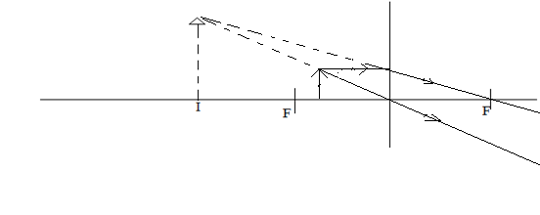
Draw a ray diagram to locate the object. (3marks)
8.What is half-life of an element (1mark)
Average time taken for the activity to decrease to half of the initial value
Or
Time taken for half of the number of radioactive nuclei present to decay
9.Explain what is observed when an uncharged sphere is brought close to a positively charged electroscope. (3marks)

10.The graph below represents values of $\frac{1}{f}$ and corresponding values of wavelength for waves transmitted in a certain medium

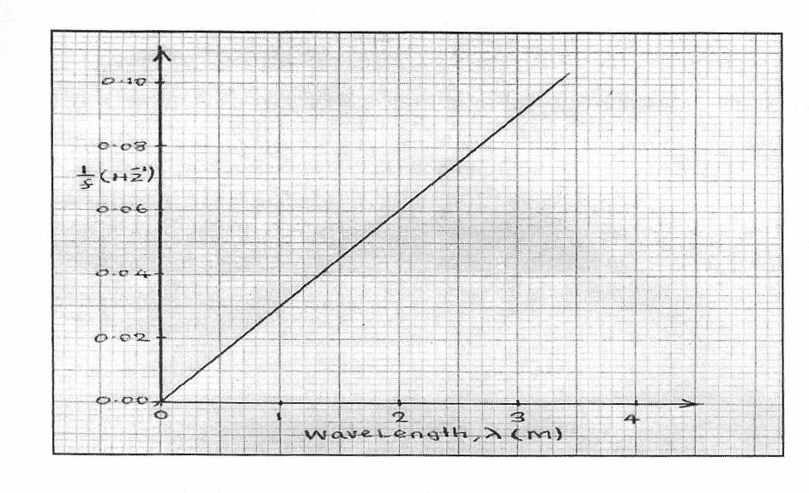
0
1
2
3
4
0.00
0.02
0.04
0.06
0.08
0.10
Wavelength, λ(m)
¹/_{f}(Hz⁻¹)

From the graph, determine the speed of the waves (3marks)

Speed = reciprocal of slope
Slope,G = 0.08-
=0.05 =0.025
2
11.Give two reasons why in domestic wiring ,bulbs are connected in parallel with one another. (2marks)
-For the bulbs to be at the same voltage at the same time
-For the bulbs to work independently even if one or several others are damaged.
12.State one necessary condition for two waves to undergo interference with each other.
They must have same frequency
13.State two modifications that can be done on a pinhole camera to take still photographs
i) The box should be painted black on the inside to eliminate reflection of light

ii) The translucent screen should be replaced by a light tight lid with a photographic film fitted on the side
iii) The pinhole should be covered with a shutter any 2 x 1 = 2mks each

14.What is the effect on X- rays passing through an electric field (1mark)
They are not deflected, since they carry no charge

SECTION B : (55marks)
Answer all the questions in this section in the spaces provided.
15. (a.) Figure 5 shows a ray of light incident on a water air interface from a source 8m deep.

i) Ray A is observed to bend as shown when it enters the air. Give a reason for the observation.
Air has a lower refractive index than water, hence refracts less as ray A enters air,
Or
Air is less optically denser than water
ii) If the refractive index of water is 1.33, calculate the angle of refraction of ray A.(2 marks)
1.33 = sin R
sin 37.41
Sin R = 1.33 sin 37.41
R= 54.067

iii) Find the actual angle of water. (2 marks)

n = 1
sin C
sin C = 1
1.33
C = 48.75º
iv) Give a reason why ray B is not travelling out water. (1 mark)

The critical angle of water has been exceeded, thus ray B is totally internally reflected.

(b.)(i.)State one possible causes of myopia. (1 mark)
- The eye lens having a short focal length
- Eye ball being too large
(ii.) State the type of lens that is used to correct myopia. (1 mark)
By use of a diverging lens /concave lens

(iii.)An object is placed 6cm from a convex lens of focal length 18cm.Determine the magnification. (2marks)
$$\frac{1}{f}= \frac{1}{u}+ \frac{1}{v}$$

$\frac{1}{18}=\frac{1}{6 }$ + $\frac{1}{v}$

V= -9cm
M = v/u
= 9/6 =1.5
16. Figure 6 below shows a photocell R in action.
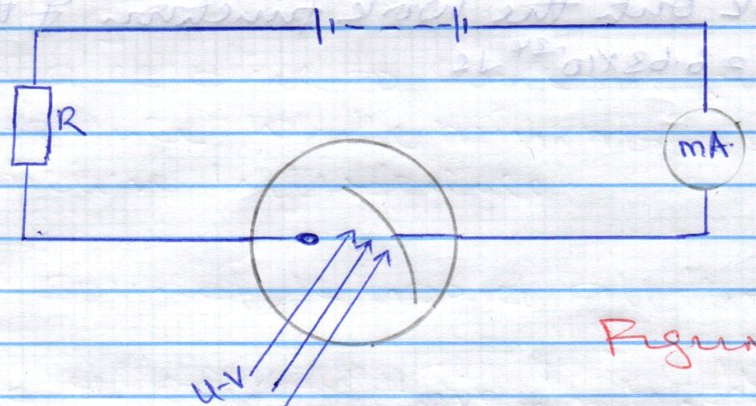

(a.)Give a reason why the cathode is curved. (1 mark)
To concentrate/focus the emitted electrons onto the anode.
(b.)State the role of resistor R in the circuit.
To control the current / limit the current
(c.)If the frequency of the radiation falling on the cathode is increased, what is the effect on the reading of the milliameter? (2 marks).
The reading increases
(d.)Explain how the set up can be modified to be used as automatic lighting system. (2 marks).
-Current flow when uv falls on the cathode.
-On the interrupting the uv beam the current is cut off.
-Used in connection to a second circuit a relay switch puts on the current in the second circuit
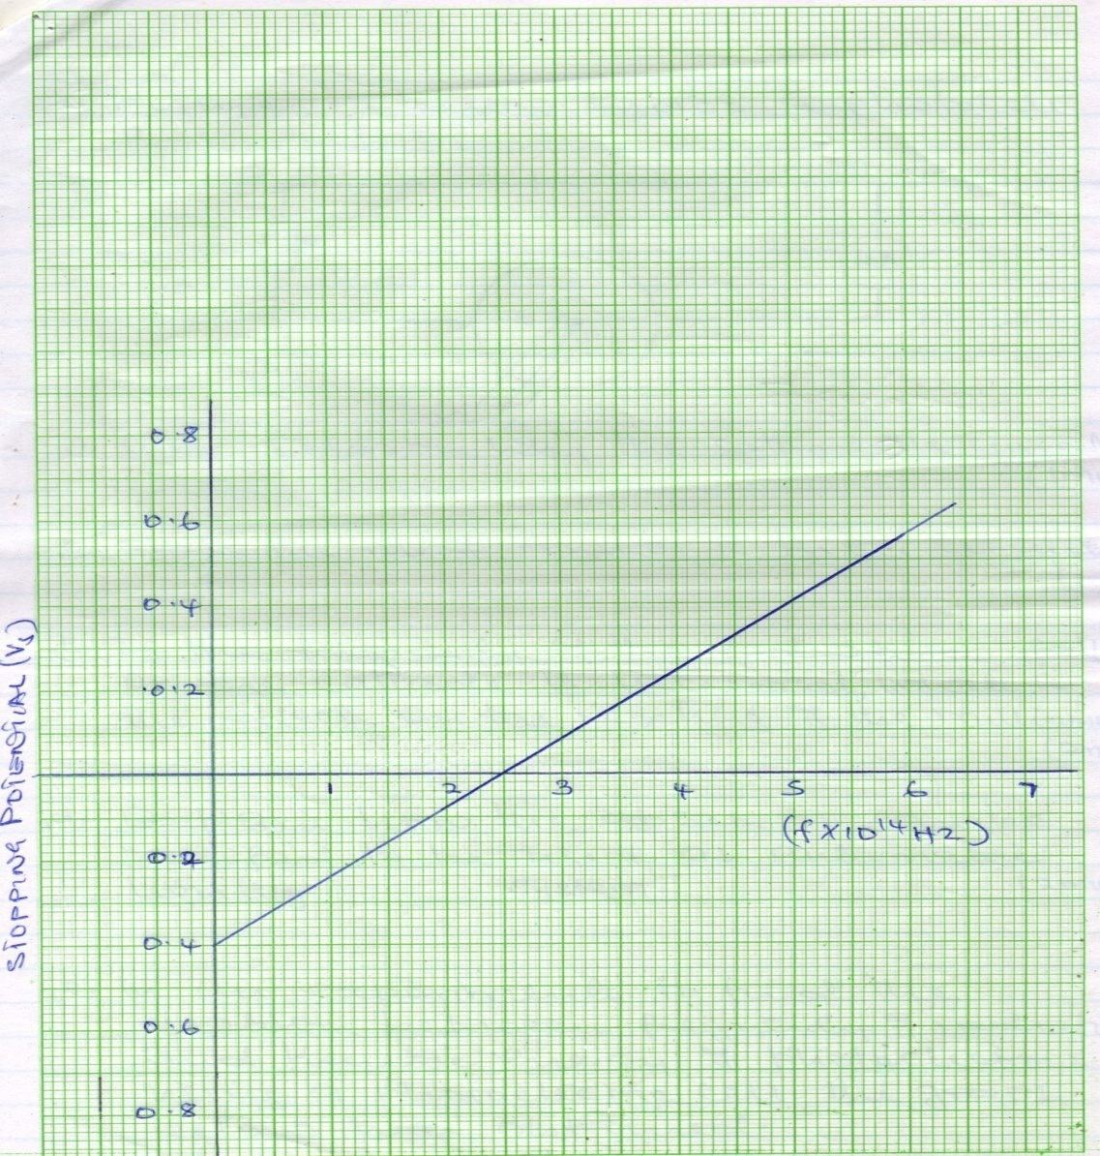
(e.)In an experiment to find the relation between frequency of radiation and kinetic energy of photoelectrons using a photoelectric cell the graph below was obtained.;

(a.)What is meant by stopping potential (1mark)
Negative potential sufficient to just stop the movement of electrons

(b.)Use the graph to determine:
(i.) the threshold frequency (1 mark)
2.5 x 10¹⁴
(ii.)Plancks constant , h,given that the stopping potential Vs is related to the frequency by the equation V_{s} =$\frac{hf }{e}-$ $\frac{wo}{e}$ ,where e is the charge of an electron,(e=1.6 x 10⁻¹⁹C) (3marks).
Slope = $\frac{h}{e}$ = $\frac{0.4-0}{\left(5-2.5\right)x 1014}$
=1.6 x 10 ⁻¹⁵ x1.6 x 10 ⁻¹⁹ Js
= 2.56 x 10 ⁻³⁴Js
(iii.)work function (2mark
wo = hfo
= 2.56 x 10⁻³⁴ x 2.5 x 10¹⁴
=6.4 x 10⁻²⁰ J
Or
$$\frac{Wo}{e}=0.4$$
Wo = 0.4 x 1.6 x 10 ⁻¹⁹
= 6.4 x 10 ⁻²⁰J

17.Figure 7, shows two parallel plate capacitors connected to a battery. Initially the switch S is open.

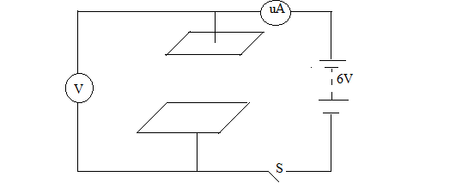figure7
(a.)The switch is now closed and left for a few seconds.

(i.) On the axes below, sketch a graph of current reading the time from time the switch is closed.
(2 marks)
I(mA)

t(s)

(ii.)Determine the reading of V after a long time. (1 mark)

6V

iii) How does the capacitance of the plates change when the plates are moved further apart.
Capacitance is lowered/reduced

(iv)The two parallel-plate capacitor in figure 7 are 0.6mm apart with effective area of 4cm².Calculate the charge stored in the capacitor after switch S is closed. (Take dielectric constant ,E= 8.85 x 10⁻¹²Fm⁻¹) (4marks)
$$C= \frac{EA}{d}$$

== $\frac{8.85X10-12X4X10-4}{0.6X10-4}$

=5.9F
Q = CV
= 5.9 X 6
= 35.4C

b) The figure 17 below shows an arrangement of three capacitors. If the effective capacitance of the arrangement is 5μF.

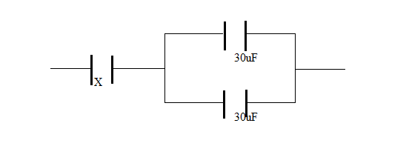

Determine the value of the capacitor X. (3 marks)
Parallel capacitance ,Cp = 30 +30 =60uF

$\frac{1}{Ceff}=\frac{1}{Cx}+ \frac{1}{Cp}$
$\frac{1}{5}= \frac{1}{Cx}+ \frac{1}{60}$
$Cx=5.455uF$

18.Define cathode rays (1mark)
A stream of fast moving electrons

b) Explain clearly the function of the control grid in the cathode ray oscilloscope. (2marks)
It controls brightness of the screen/controls the number of electrons passing through it.
When more negative w.r.t. cathode, fewer electrons pass through it and vice versa.
(c ) The figure 7 shows a display of an a.c signal on the CRO screen.
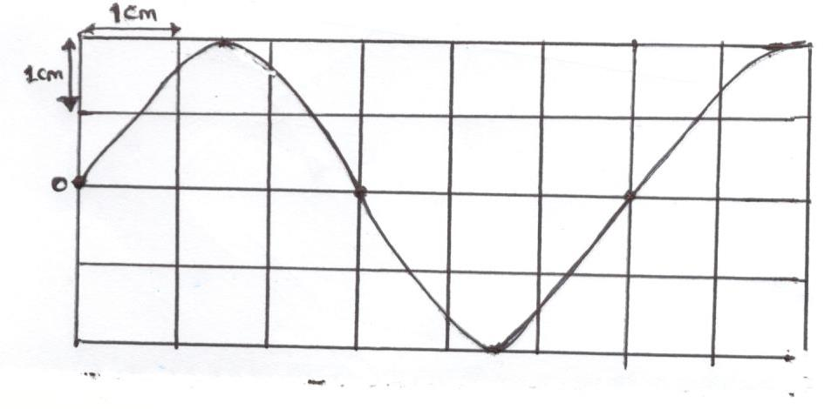
Given that the time-base setting is 100mS per cm and y-gain (sensitivity) is 25V/cm. Determine:
- the frequency of the wave (3marks)
T = 100 x 6 = 600ms
F= 1/T = 1/(600 x 10⁻³) = 1.667Hz.

- the peak-voltage (3marks)

= Y-gain x no. of division
= 2 x 25
=50V

(d) State reason why magnetic fields are preferred to electric fields in deflecting the beam of electrons in CRT television set.
-they provide a wider deflection
(e.)What property of cathode rays does the formation of maltese cross on CRO screen suggest.
They travel in straight line
19a) An electric bulb is rated 210w,what does it mean. (1mark)
The bulb converts 210 joules of electrical energy to light and heat every second.

b) Two light bulbs x and y are rated 60w, 220v and 80w, 220v respectively.
- Determine which of the bulbs draws more current.
P =IV
X
I= 60/220 =0.2727A
Y
I=80/220 = 0.3636A
Y
- Calculate the cost of using the two bulbs, if the bulbs above are used for 10 hours daily for 10 days. (1kwhr = ksh.7.20). (3marks)
Total units =140 x10 x 10 =14000/1000= 14kWh
Cost = 14 x 7.20
= 100.8/=
c) A cell supplies a current of 2.4 A through a 2.4Ω resistor and a current of 4A through a 1.4 Ω resistor. Calculate the e.m.f ( E ) and the internal resistance ,r, of the cell. E=I(R + r)
E = 2.4(2.4 + r) ……..(i.)
E = 4( 1.4 + r) ……(ii.)
r = 0.1 ohms E =6.0V
d) State one reason why in modern domestic wiring circuit breakers are preferred to fuses.
Circuit breakers are mechanically reconnected (switched on), thus economical whereas fuses are replaced.

