METALS
1.
When magnesium metal is burnt in air it reacts with both oxygen and Nitrogen gas giving a white ash like substance. Write two equations for the two reactions that takes place.

2.
When excess Carbon (II) Oxide is passed over lead oxide in a combustion tube, lead (II) oxide is reduced.
(a) Write an equation for the reaction which took place ( 1 mk)
(b) What observations was made in the combustion tube when the reaction was complete ( 1 mk)
(c) Name another gas which would be used to reduce lead (II) oxide ( 1 mk)

3.
When the oxide of element “H” was heated with powdered carbon, the mixture glowed and carbon (IV) oxide gas was formed. When the experiment was repeated using oxide of “J” there was no apparent reaction
(a) Suggest one method that can be used to extract element J from its oxide
( 1 mk)
(b) Arrange element H, J and carbon in the order of their decreasing reactivity
( 1 mk)
4.
Study the flow chart below and answer the question that follows
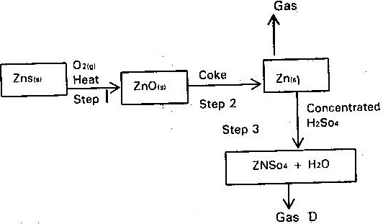

(a) State the conditions necessary for the reaction in step 2 to occur ( 1 mk)
(b) Name
(i) Gas P ( 1 mk)
(ii) One use of Zinc ( 1 mk)

5.
The set up below was used to obtain a sample of iron

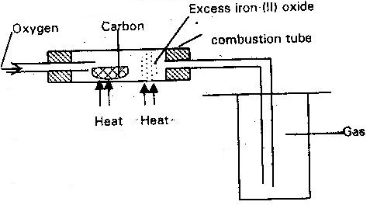

Write two equations for the reactions which occur in the combustion tube
( 2 mks)
6.
Dry carbon (II) oxide gas react with heated lead (II) oxide as shown in the equation below
(a) Name the process undergone by the lead (II) Oxide ( 2 mks)
(b) Give a reason for your answer (a) above
(c) Name another gas that can be used to perform the same function as carbon gas in the above reaction ( 1 mk)

7.
In the industrial extraction of lead metal, the ore is first roasted in a furnace. The solid mixture obtained is then fed into another furnace together with coke limestone and scrape iron. State the functions of each of the following in this process.
(a) Coke ( 1 mk)
(b) Scrape iron ( 1 mk)
(c) Limestone ( 1 mk)

8.
Study the flowchart and answer the questions that follows
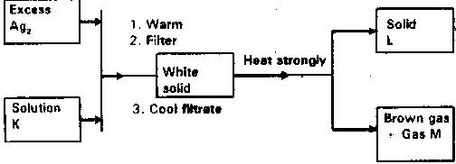

Identify
(a) Solution K
(b) Solid
(c) Gas M

9.
The flow chart below shows steps used in the extraction of zinc form one of its
Ores.
Zinc carbonate ore
Powdered zinc carbonate ore
Concentrated zinc carbonate ore
Zinc metal
Zinc oxide
Crushing
Step 1
Step 2
Step 3
Heat
Gas
Coke
Step 4

(a) Name the process that is used in step 2 to concentrate the ore. ( 1 mk)
(b) Write an equation for the reaction which takes place in step 3 ( 1 mk)
(c) Name one use of zinc other than galvanizing ( 1 mk)

10.
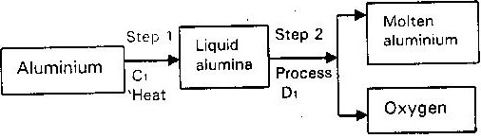
During the extraction of aluminium from its ores; the ore is first purified to obtain alumina. The flow chart below shows the stages in the extraction of aluminium from alumina.

(a) Name
(i) Substance C₁ ( 1 mk)
(ii) Process D₁ ( 1 mk)

(b) Give two reasons why aluminium is used extensively in making of cooking pans ( 1 mk)

11.
The flow chart below outlines some of the process involved in extraction of copper from pyrites. Study it and answer the questions that follows
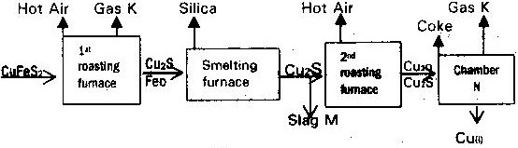

(a)
(i) Name gas “k”
(ii) Write an equation for the reaction that take place in the 1st roasting furnace
( 1 mk)
(iii) Write the formula of the cations present in the slag “M”
(iv) Identify gas “P”
(v) What name is given to the reaction that take place in chamber N. Give a reason for your answer?

(b) The copper obtained “M” is not pure. Draw a labeled diagram to show the set up you would use to refine the copper by electrolysis. (2mks)

(c) Given that the mass of copper obtained from the above extraction was 210 kg. Determine percentage purity of the ore (Copper pyrite) if 810 kg of it was fed to the 1st roasting furnace (4mks)
(Cu= 63.5) (Fe = 56) (S= 32)

(d) Give two effects that this process could have on the environment (2mks)

12.
The flow chart below illustrates the industrial extraction of lead metal. Study it and answer the questions that follows
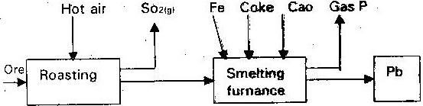

(a) (i) Name the ore that is commonly – used in this process ( 1 mk)
(ii) Explain what take place in the roasting furnace ( 1 mk)
(iii) Identify gas “p” ( 1 mk)
(iv) Write the equation for the main reaction that takes place in the smelting furnace ( 1 mk)
(v) Give two environmental hazards likely to be associated with extraction of lead
(vi) What is the purpose of adding iron in the smelting furnace? (1 mk)
(b) Explain why hard water flowing in lead pipes may be safer for drinking them soft water flowing in the same pipes (3mks)
(c) State one use of lead other than making lead pipes (1 mk)

13.
The raw material for extraction of aluminum is bauxite.
(a) Name the method that is used to extract aluminium from bauxite (1 mk)
(b) Write the chemical formula for the major components of bauxite (1 mk)
(c) (i) Name the major impurities sin bauxite (3mks)
(ii) Explain how the impurities in bauxite are removed (3mks)

(d) Crayolite is used in the extraction of aluminium from bauxite. State its function (1 mk)
(e) Describe how carbon (IV) oxide is formed during the extraction of aluminium (2mks)
(f) Aluminum is a reactive metal yet utensils made from aluminium do not corrode easily. Explain this observation

14.
The extraction of iron from its ore takes place in the blast furnace. Below is a simplified diagram of a blast furnace. Study it and answer the questions that follow.
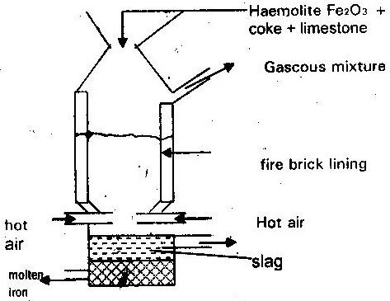

(a) (i) One of the substances in the slag (1 mk)
(ii) Another iron ore material used in the blast furnace (1 mk)
(One gas which is recycled) (1 mk)
(b) Describe the process which leads to the formation of iron in the blast furnace

(c) State the purpose of limestone in the blast furnace (1 mk)
(d) Give a reason why the melting point of iron obtained from the blast furnace is 1200⁰ while that of pure iron is 1535⁰C (1 mk)
(e) State two uses of steel (2mks)

15. The flow chart below shows a sequence of chemical reactions starting with copper. Study it and answer the questions that follow
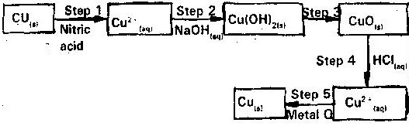

(a) In step 1, excess 3M nitric acid was added to 0.5 of copper powder
(i) State two observations which were made when the reaction was in
progress (2mks)
(ii) Explain why dilute hydrochloric acid cannot be used in step 1 (1 mk)
(iii) I. Write the equation for the reaction that took place in step 1 (1mk)
II. Calculate the volume of 3M nitric acid that was needed to react completely with 0.5g of copper powder (Cu= 63.5) (3mks)
(b) Give names if the type of reactions that took place in steps 4 and 5 (1 mk)
(c) Apart from the good conductivity of electricity, state two other properties that make it possible for copper to be extensively used in the electrical industry (2mks)

16. Study the flow chart below and answer the questions that follow
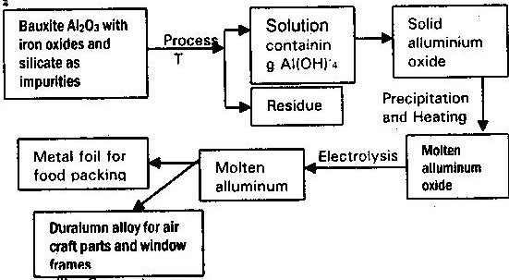

(i) Suggest a purpose for the industry process represented by the flow chart
(1 mk)
(ii) Explain how process T is carried out (2mks)
(iii) Explain why it is necessary to heat aluminum oxide before electrolysis is
carried out (1mk)
(iv) Suggest a reason to why carbon is not used for reduction of aluminium
Oxide (1 mk)
(v) What properties of aluminum and the alloy make them suitable for use indicated? (2mks)

17. The flow chart illustrates the extraction of zinc and preparation of Zinc (II) sulphate crystals. Study it and answer the questions that follow
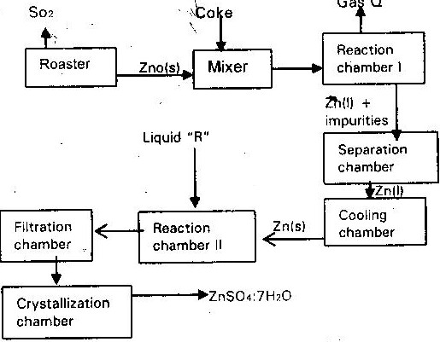

(a)
(i) Name
I. Gas Q (1 mk)
II. Liquid R (1 mk)
(ii) Write an equation for the reaction that takes place in
    - Chamber I (1 mk)
    - The Roster (1 mk)
    - Chamber II (1 mk)
(iii) Given that the zinc sulphide ore contain 45% of Zinc sulphate by mass calculate
I. The mass in grains of Zinc sulphide that would be obtained from 250 kg of the ore (1 mk)
II. The volume of sulphur (IV) oxide (So₂) that would be obtained from the mass of zinc (1 mk)
III. Sulphide obtained in 1 above at room temperature and pressure (Zn = 65.4) (S = 32.0) molar gas volume = 24 dm³
(b) In such an experiment sulphur (IV) Oxide may keep escaping to the atmosphere. Explain how this could affect the environment. (2mks)

(c) Suggest one other man manufacturing plant that could be set up near Zinc extraction plant. Give a reason for your answer

18. Iron Pyrites was heated in air to give Iron (III) oxide and a gas X: This is also when a yellow powder is burned in limited amount of air.
(i) Identify the yellow powder (1 mk)
(ii) Identify gas X (1 mk)
(iii) Write a chemical equation to show the reaction between gas X and aqueous Sodium Hydroxide (1 mk)

19. Hydrogen was passed over heated iron (III) oxide, but no reaction occurred. Iron (III) oxide was heated with carbon, Iron was formed and after separation it was dissolved in dilute sulphuric acid. A gas “Y” was evolved.
(a) (i) Is the reaction between hydrogen and iron (III) oxide physical or
chemical explain (2mks)
(ii) Explain why carbon reached with iron (III) oxide while hydrogen did not (2mks)
(iii) Identify gas Y (1 mk)
(b) Iron window frames corrode quickly unless carefully protected but aluminum window frames are resistant to corrosion
(i) Give the chemical name of the substance formed when iron rust
(ii) Why does aluminium items does not corrode as quickly as iron (1 mk)
(iii) Explain why galvanized iron is resistant to corrosion even when the protective layer of zinc is broken (2mks)
20. Study the table below of oxides and sulphides formed by different elements and answer the questions that follow.

Elements | Oxides | Sulphides
Copper | CUO, CU₂O | CuS, Cu2S
Hydrogen | H₂O | H₂S
With reference to the periodic table, what is the relationship between oxygen and sulphur (1 mk)
21. Two metals “A” and “B” have close packed and body centered cubic respectively. Which metal has the highest melting point ( 1 mk)
22. Aluminium metal is a good conductor and is used for over head cables. State any two other properties that make aluminium suitable for this use.
23. The table below shows the properties of substances K, L, M and N

Substance | Reaction with oxygen | Melting point | Conductivity
Substance | Reaction with oxygen | Melting point | Solid | Molten
K | Unreactive | High | Good | Good
L | Reactive | Low | Poor | Poor
M | Unreactive | High | Good | Good
N | Unreactive | Low | Good | Good

Select the substance which is likely to be
(a) Copper metal (1 mk)
(b) Magnesium chloride

24. (a) An ore is suspected to containing mainly iron. Describe a method that can
be used to confirm the presence of iron in the ore (4mks)
(b) Excess Carbon (II) oxide was passed over a heated sample of an oxide of iron as shown in the diagram below. Study the diagram and the data below it to answer the question that follows
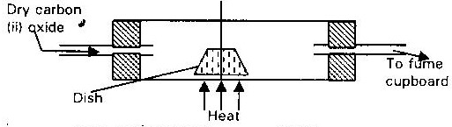

Mass of empty dish 10.98g
Mass of empty dish + oxide of iron 13.30g
Mass of empty dish + residue 12.66g
(i) Determine the formula of the oxide of iron. Relative mass of oxide of iron is 232, Fe= 56, O = 16 (2mks)
(ii) Write equation for the reaction which took place in the dish (1 mk)
(c) Corrosion is a destructive process in which iron is converted into hydrated (III) Oxide. State
(i) Two conditions necessary for rusting to occur (1 mk)
(ii) One method used to protect iron from rusting (1 mk)
(d) Explain why it is not advisable to wash vehicles using sea water (2mks)

25. Lithium metal react with water less vigorously than sodium metal explain (1 mk)

